MWD Capstone – Weekly Checkup

# Instructions:

To ensure steady progress, students must submit a weekly check-in that includes:

Screenshot of GitHub Activity View: Demonstrating commits and contributions to the project repository.

Screenshot of Current Website State: Showing updates made over the week.

Brief Progress Report: A short summary (3-5 sentences) detailing what was accomplished, challenges faced, and plans for the next week.

# Screenshot of GitHub Activity View:

(Insert here)

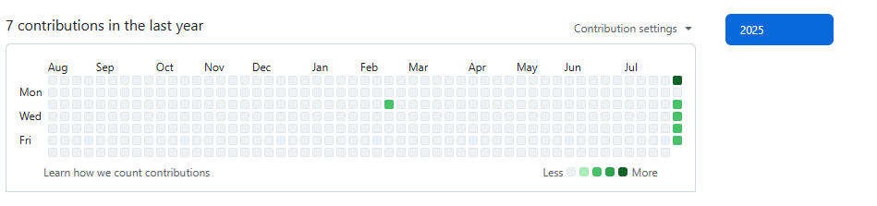

# Screenshot of Current Website State:

(Insert here)

# Brief Progress Report:

(Insert here)

This is my 2nd face of my capstone project

**NOTE**: Failure to submit consistent progress updates may impact your final grade. If you have any issues or concerns regarding your project, please contact your instructor for assistance.